Key for Take-Home Assignment 01

1. The four peaks in the spectrum for benzene appear at 267.9 nm with an absorbance of 0.151, at 260.3 nm with an absorbance of 0.561, at 255.1 nm with an absorbance of 0.306, and at approximately 250 nm with an absorbance of approximately 0.1. Note that the last of these peaks appears as a shoulder on the peak at 255 nm, which makes it difficult to determine its exact wavelength and absorbance.

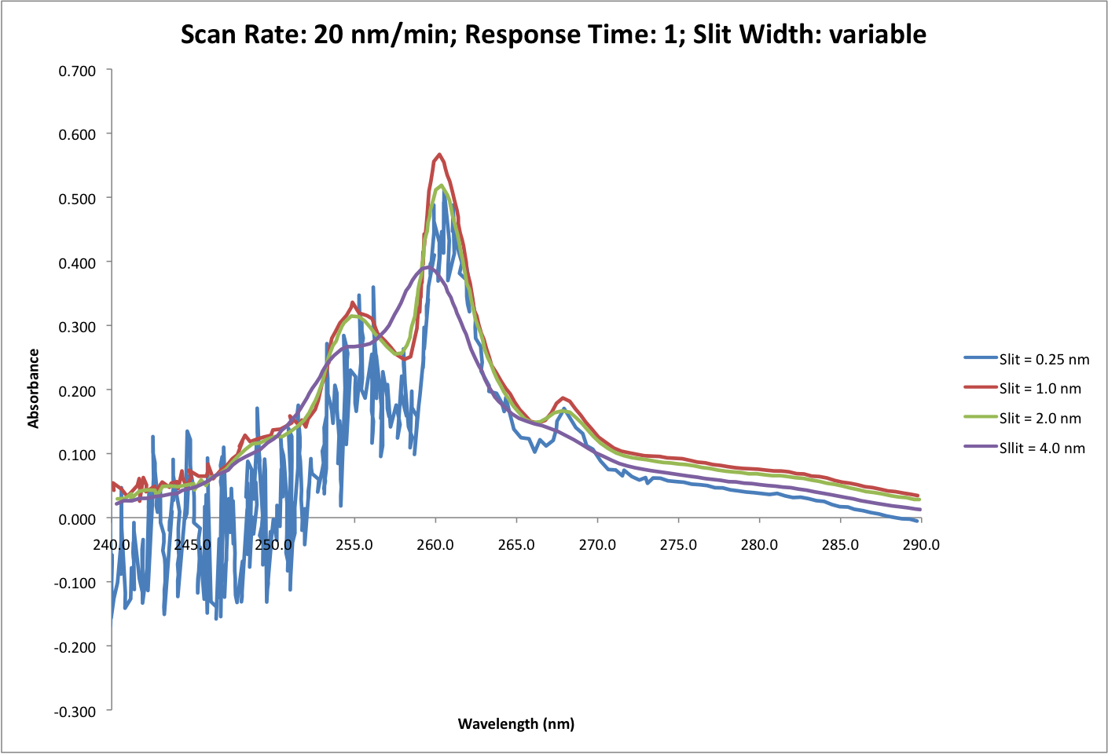2. The figure to the right shows the effect of slit width on the spectrum for benzene. The most obvious thing to note in this figure is that the smallest slit width of 0.25 nm results in very noisy signal at shorter wavelengths, which is a result of the lower throughput of source radiation. The largest slit width of 4.0 nm results in a loss of resolution between absorption bands and, more important, a distinct shift in the wavelengths of peak absorbance. In addition, there is a decrease in the maximum absorbance as we increase the slit width from 1.0 nm to 2.0 nm to 4.0 nm.

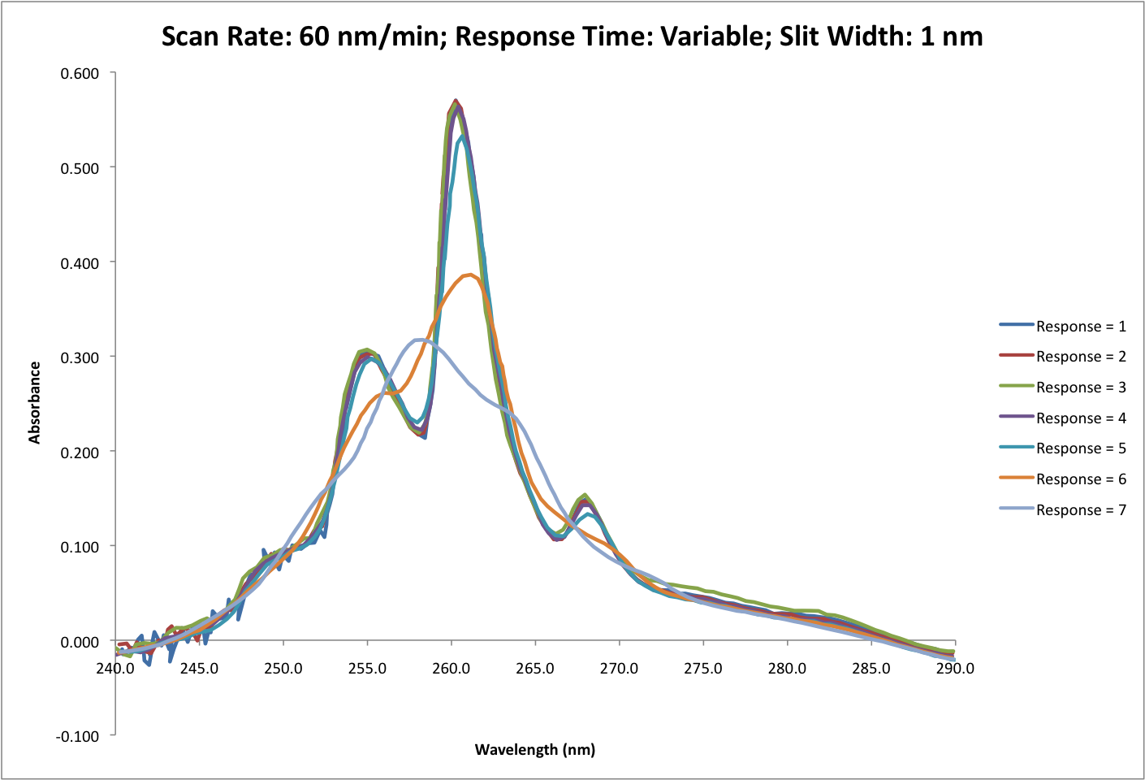

The figure to the left shows the effect of response time on the spectrum of benzene. The most obvious thing to note here is that the three slowest response times (responses of 5, 6, and 7, which correspond to response times of 2.0, 5.0, and 10.0 seconds) lead to a reduction in the maximum absorbance, a decrease in resolution, and a shift in the wavelength of peak absorbance. There is a subtle effect of response time on noise with the fast response times resulting in an increase in noise at shorter wavelengths.

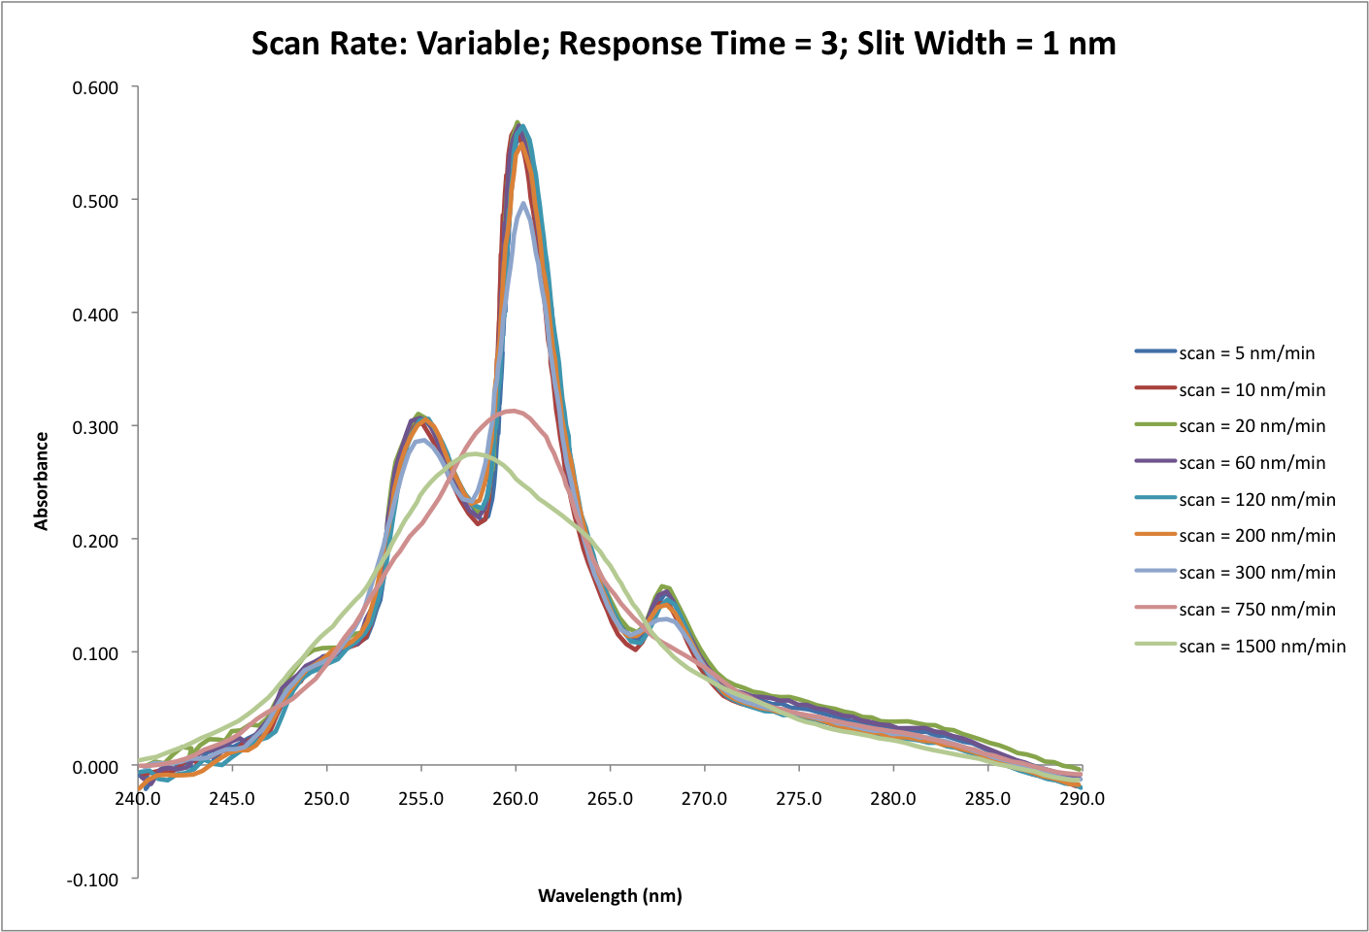

The figure to the right shows the effect of scan rate on the spectrum of benzene. The most obvious things to note here are that a scan rate ≥200 nm/min leads to a reduction in the maximum absorbance, and that a scan rate of ≥300 nm/min results in a decrease in resolution and a shift in the wavelength of peak absorbance. There is a small increase in noise, particularly at shorter wavelengths, when the scan rate exceeds 10 nm/min, but noise is not a significant issue at any of these scan rates.

3. We are asked to choose conditions that will produce acceptable accuracy in absorbance and peak position with a short analysis time. The only reasonable slit width is 1.0 nm as it gives the maximum absorbance and has little noise. For the response time, settings of 1–4 are acceptable, although choosing a larger value will minimize noise. Any scan rate ≤200 nm/min will work fine. Given the need to balance time and quality, I would use a 1.0 nm slit with a response time of 3 and scan rate of 120 nm/min.